Motion Lab

It is a lovely Saturday evening in the city of Dortmund. The time is 6:00 pm. It is the perfect setting for a football match between Borrusia Dortmund and FC Shalke 04: the pitch looks brilliant, the stands are filled with excited fans sporting the distinct Dortmund yellow, and the weather is perfect. Both teams and the referee are on the pitch at Stadion Signal Iduna Park.

The game begins with a kickoff. Robert Lewandowski touches the ball to İlkay Gündoğan for 5 seconds (the ball has no velocity because it does not move in the horizontal plane). Gündoğan then passes the ball 10 meters to Sven Bender (the pass takes 3 seconds). Bender immediately passes the ball back 30 meters to Roman Weidenfeller (this took 5 seconds). Weidenfeller then clears the ball 50 meters in 10 seconds at a variable velocity.

Dortmund goes on to win the game 3-0.

- Purpose: To become familiar with the concepts of position vs time graphs as well as the
proper use of a motion detector.

- Equipment: Lab Quest and a Motion Detector.

- Procedure: 1. The ball starts off in the center of the field at a standstill (as far as the x-axis
is concerned) for 10 seconds
2. It is then passed back 10 meters away to the midfielder at 2 meter / second
3. It is played back 30 meters to the goalie at 6 meters/second
4. The ball is then punted 50 meters across the field at a velocity of 5 meters /
second.
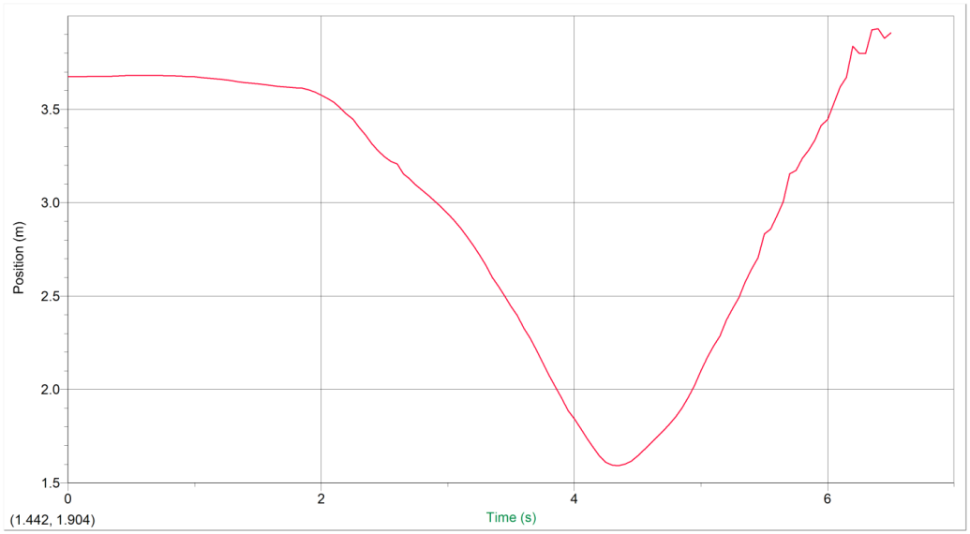
Data / Data Analysis:
Sample Data
0 3.674 0.014 -0.016
0.05 3.674 0.014 -0.035
0.1 3.675 0.012 -0.056
0.15 3.676 0.007 -0.054
0.2 3.676 0.004 0.001
0.25 3.676 0.006 0.082
0.3 3.676 0.013 0.132
0.35 3.677 0.025 0.072 0.45 3.677 0.025 0.072 0.55 3.68 0.002 -0.092
0.4 3.679 0.025 -0.069 0.5 3.68 0.007 -0.092 0.6 3.681 -0.003 -0.06

- Conclusion: During this lab, we expanded our knowledge of the proper use of a Lab
Quest and a motion detector. Throughout the process, the data remained
consistent and no surprising results were found. The two graphs were very
similar, but the main difference was that the object never completely stopped
in the computerized graph. The main source of error would have been
mistakes with using the motion detector, but these were minimized through
multiple runs.

