Moment of Inertia Lab

- Purpose: To experimentally determine the moment of inertia for a bicycle wheel through
calculation of the acceleration.

- Equipment: Computer / Microsoft Office Suite

- Procedure: 1. Set up the calculations for the tension based off of the sum of the forces on
the block and the sum of the torques on the wheel.
2. Set the tensions for the block and the torques equal to each other.
3. Obtain the expression for I.
4. Use the video to take the measurements to calculate the acceleration.
5. Use the calculated acceleration to solve for the moment of inertia.

- Data / Data Analysis: On Excel Worksheet

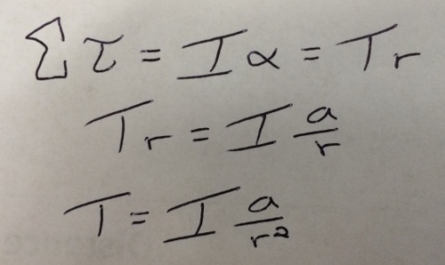
- Calculations:
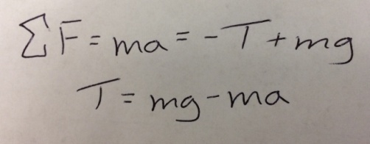

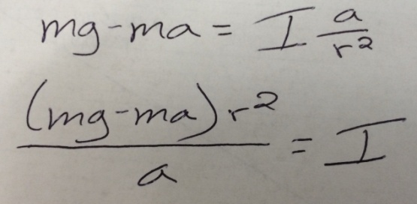

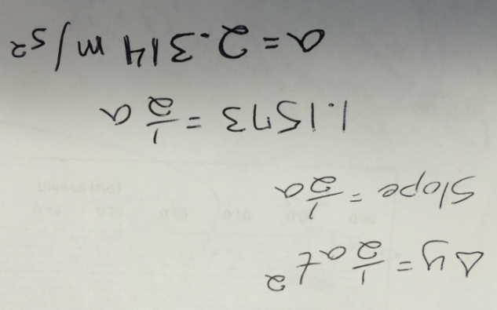
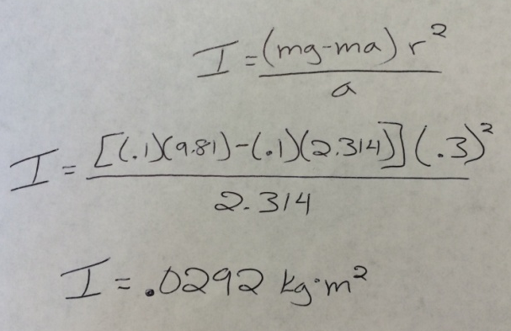

- Conclusion: During this lab, I worked with solving for the acceleration based off of
calculations of position vs time squared. Throughout the process, the data was minimally spread due to various sources of errors. The main source of error would have been human error in recording the measurements from the video.

